**Business Problem**

In recent years, City Hotel and Resort Hotel have seen high cancellation rates. Each hotel is now dealing with several issues as a result, including fewer revenues and less than ideal hotel room use. Consequently, lowering cancellation rates is both hotel’s primary goal to increase their efficiency in generating revenue, and for us to offer through business advice to address this problem.

The analysis of hotel booking cancellations as well as other factors that have no bearing on their business and yearly revenue generation are the main topics of this report.



**Assumptions**

1. No unusual occurrences between 2015 and 2017 will have a substantial impact on the data used.

2. There are no unanticipated negatives to the hotel employing any advised technique.

3. The hotels are not currently using any of the suggested solutions.

4. The biggest factor affecting the effectiveness of earning income is booking cancellations.

5. Clients make hotel reservations the same year they make cancellations.

**Research Questions**

1. What are the variables that affect hotel reservation cancellations?

2. How can we make hotel reservations cancellations better?

3. How will hotels be assisted in making pricing and promotional decisions?

**Analysis and Findings**

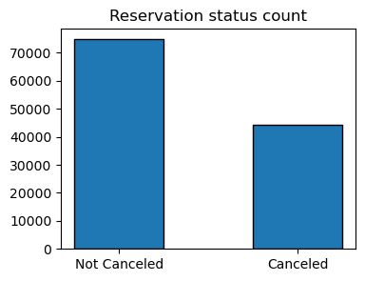

The above bar graph shows the percentage of reservations that are canceled and those that were not canceled. We can see that there are still a significant number of reservations that have not canceled. But we should also see that cancellation rate is more than half of not canceled.

Around 37% of clients who canceled their reservation, which has significant impact on the hotel’s earnings.

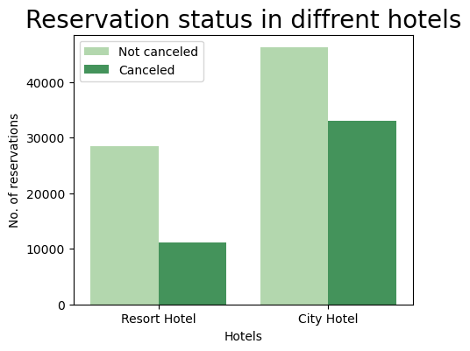

When analysed the Reservation status, it is found that in comparison to Resort Hotels, City Hotels have more bookings. It’s possible that Resort Hotels are more expensive than those in cities.

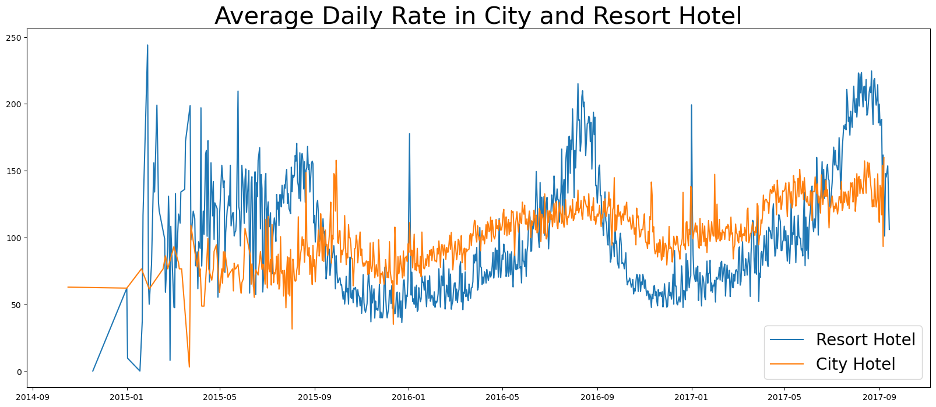

The line graph above shows that, on certain days, the average daily rate for a City Hotel is less than that of a Resort Hotel. It may be possible that weekends and holidays may see a rise in Resort Hotel rates.

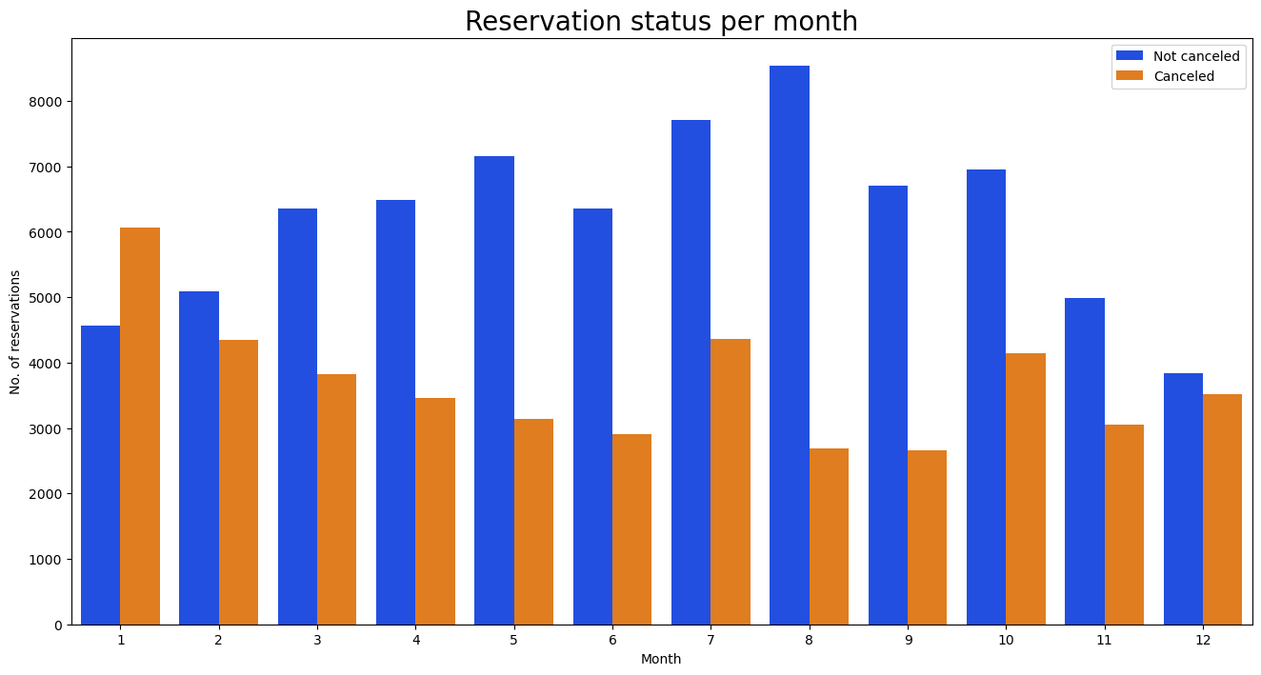

We have created the group bar graph to analyse month-wise highest and lowest reservation levels according to Reservation status. We can see that number of not canceled reservations are high and canceled reservations are low in the month of August. Whereas January is the month with the most canceled reservations.

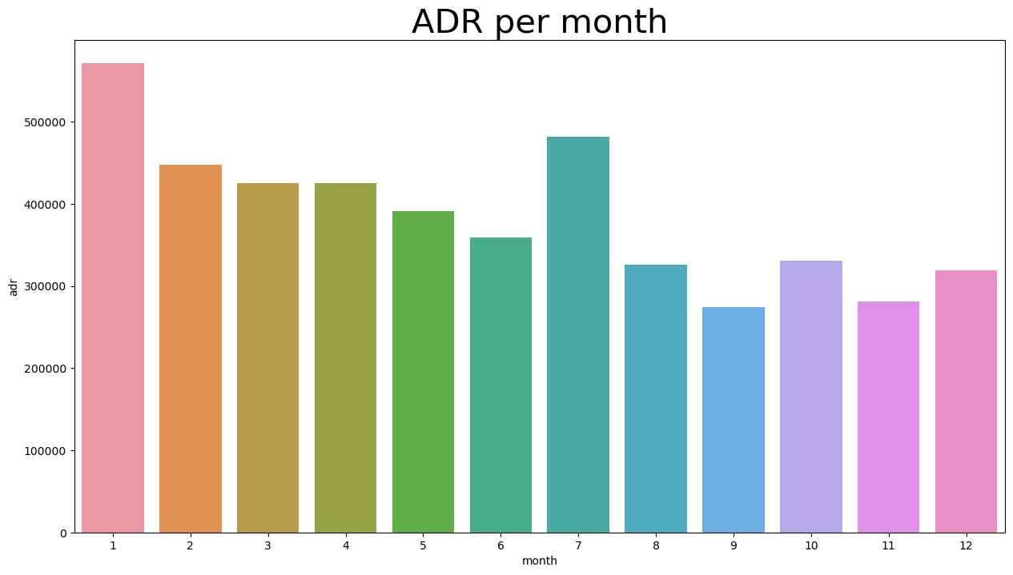

This bar graph demonstrates that cancellations are most common when prices are greatest and are least when they are lowest. Therefore, the cost of the accommodation is solely responsible for the cancellation.

Now let’s see which country has the highest reservation canceled.

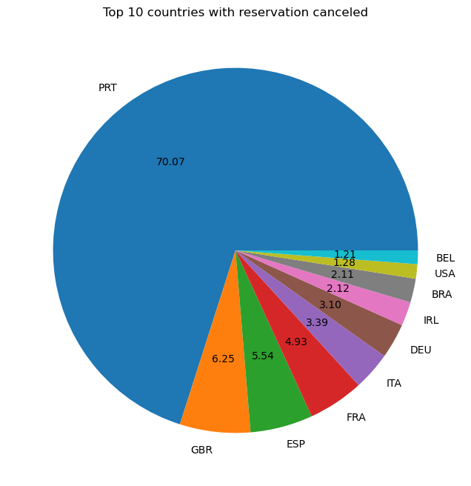

Only top 10 countries have been taken based cancelation of reservations. The top country is Portugal with the highest number of cancellations.

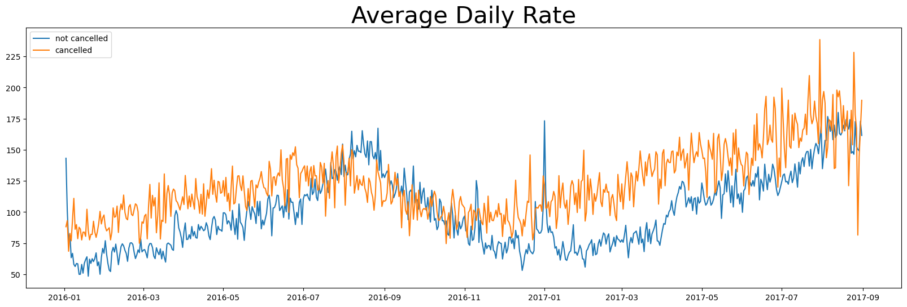

As seen in the graph, reservations are cancelled when the average daily rate is higher than when it is not canceled. It clearly proves all the above analysis, that higher price leads to higher cancellation.

**Suggestions**

1. Cancellation rates rise as the price does. In order to prevent cancellations of reservations, hotels could work on their pricing strategies and try to lower the rates for specific hotels based on locations. They can also provide some discounts to the clients.
2. As the ratio of cancellation and not cancellation is higher in the Resort Hotel than the City Hotel, hotels should provide a reasonable discount on the room prices on weekends or on holidays.
3. In the month of January, hotels can start campaigns or marketing with a resonable amount to increase their revenues as the cancellation is highest in that month.
4. They can also increase the quality of their hotels and their services mainly in Portugal to reduce the cancellation rate.
5. The hotels can also give discount vouchers to their regular customers to improve there bonding which can help in minimizing the cancellation rates.
6. Also hotels should make ease of access for online booking where cancellation rates are higher.